**Programming Assignment 2 Part 2**

**1-**

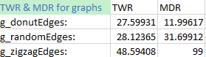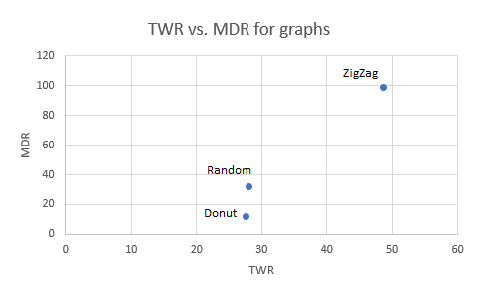

**2-**

**Donut Graph:**

Since this graph had the lowest MDR out of all the other graphs, then it makes sense that we choose the MST version of this graph. In addition, it appears that its TWR also was the best out of all of the graphs but not by much. Hence, it makes more sense that we focus on the MDR and therefore **pick its MST.**

**Random Graph:**

As for the random graph, it appears that its TWR is a significant amount lower than its MDR. Hence, we would pick its **shortest path tree** rather than its MST

**ZigZag Graph:**

Overall, this graph just sucks. It does quite a lot worse than the other two graphs. However, its TWR is about half of its MDR, so for that reason I would pick the **shortest path tree** version for this graph.

**Closing comments:**

This programming assignment was pretty informative, and I can see now why the structure for a lot of things is usually “donut” shaped with the source node being in the middle. For example, the “donut” graph reminded me of the structure of a “Clash of Clans” village and how the source node/town hall (and often also the soldiers/barbarians) are usually placed in the middle. However, I can see why other structures would be used when one criteria is much more important than the other such as when trying to distribute resources like food and the weight of every edge is pretty small.

**3-**

